**Abbas Sayed Habib Ali Abbas**

House 2046, Road 3357, Almalkeya 1033

Mobile: 33906047 - 36704069

Email: [ssedoonn@gmail.com](mailto:ssedoonn@gmail.com)

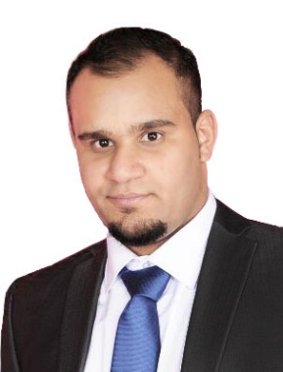**Personal Information:**

Nationality: Bahraini

CPR: 920807313

Date of Birth: 13 / 8 / 1992

Place of Birth: Malkeya

Marital Status: Married

**Education:**

* Al-Jabriya Secondary School
* Al-Farabi Intermediate boys school

**My Experiences:**

* Mcdonalds (2011 – 2012)
* Security guard (2012-2017)

**Additional Skills:**

Languages: Good commands of spoken and written English & Arabic

Computer Skills: Microsoft office

Interpersonal Skills: Team working and leadership, Good communication skills, Presentation with high confident.

**Objectives:**

The main goal for me is to reach the highest level that I deserve in my career by helping others in my role in any community or company to reach the success that I working hard to get it with full of experience and professionally.